Industrial Smoke Stack

* The Height of Smoke Stack is dependent on the type of Industry and Processes involved in it.

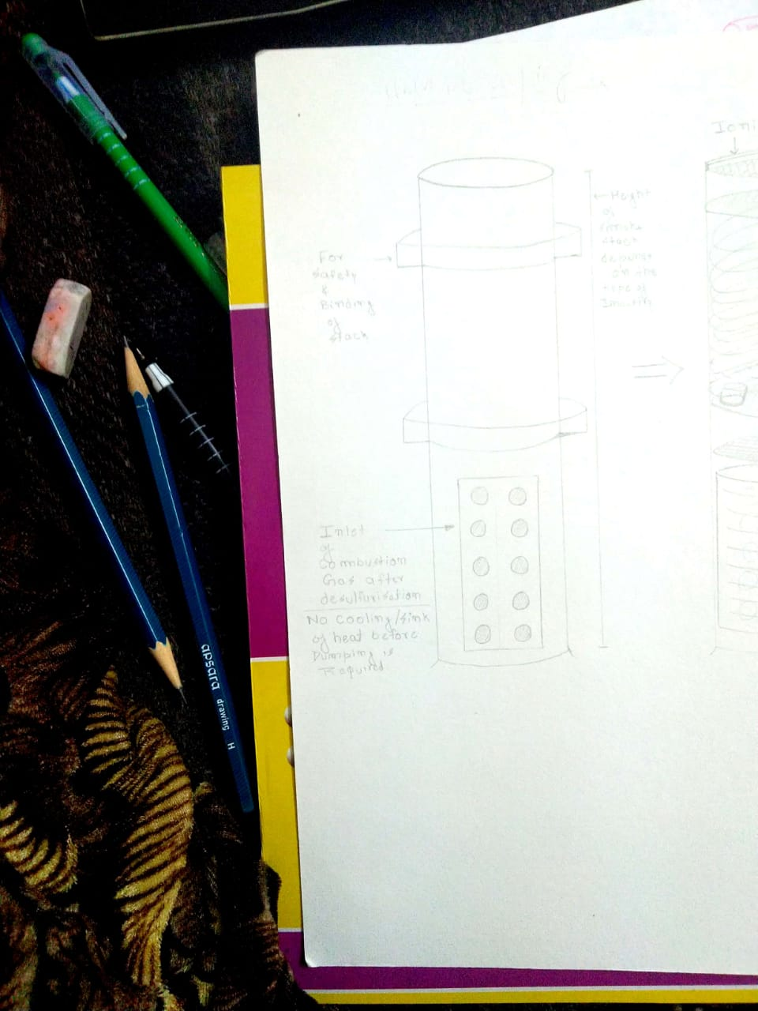 [Height Of Smoke Stack by Gov.](https://www.trc.govt.nz/assets/Documents/Plans-policies/AirPlan/raqp-appendix8.pdf)

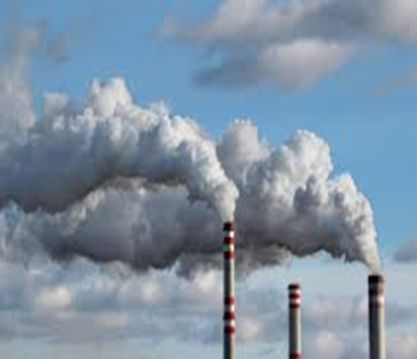

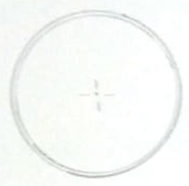

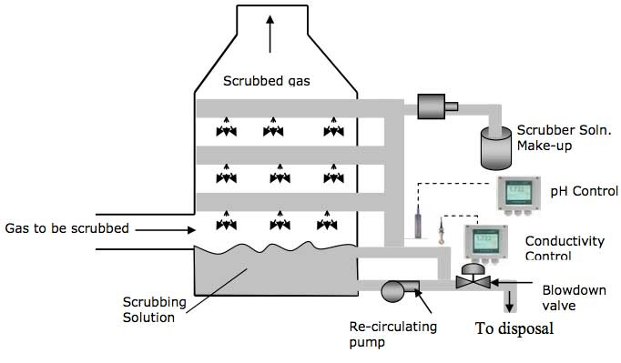

* The Smoke comes from the incomplete Combustion of a Substance. So, it’s important to Dry the Fuel from Moisture.
* According to GRUBBS LAB, CALTECH the most common in all type of Industries is So2 which is generally Neglected. It can cause Acid Rains, Haze, Smog and have Largest Public Health Impact, and that is why it is taken as reference for certification.
* Flue Gases terminate where the Combustion gases disperse Quickly.
* After Coming from Boiler, Untreated Hot Gases is de-sulfurised by Scrub Soln to give Gypsum as Byproduct which can be used in Building, as ULTRA-LOW SULFUR Disel is Costly to Operate .

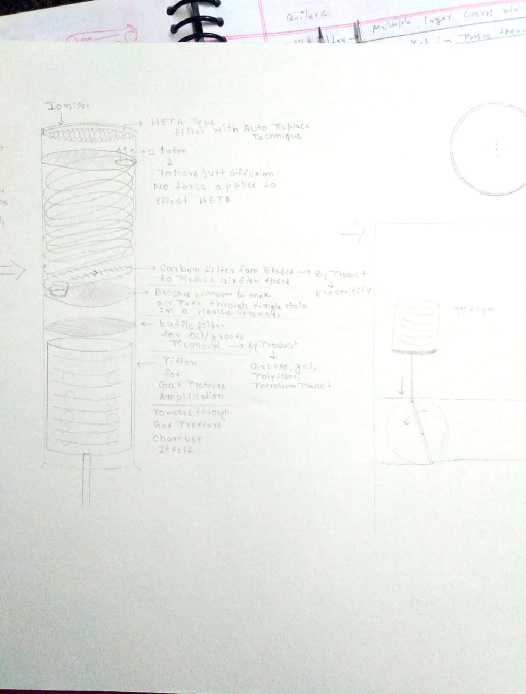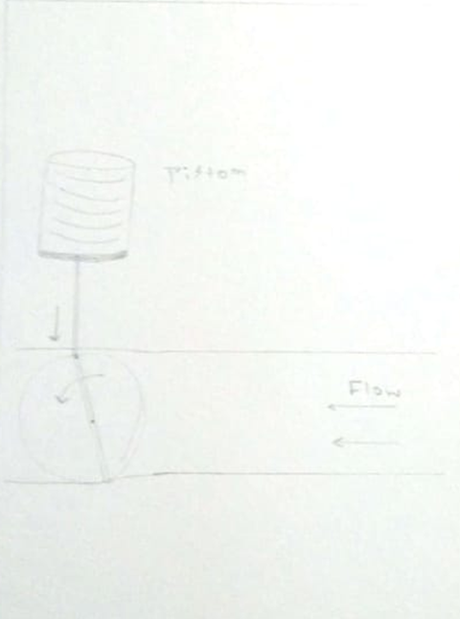

* The piston Pushes air Instantaneously and a limited amount of it So, that it purifies efficiently, to Baffle Filter which Removes oil and Grease giving Petroleum By-Products.
* Now, I put a Barrier type structure inside with a hole sideways, such that it makes air go in Hexical form to Increase Distance of air flow for more drag.
* There are Hexically Plotted Carbon Filter Fans to Lower the Speed of Gas Flow and Generate Electricity. The Carbon From it is Extracted to make Carbon Sheets.
* Now, till last the flue speed is down to such a extent that air pressure is now just slightly greater than 1 atm. So, that air could just diffuse from it and not to effect HEPA anyways.
* Lastly an Ioniser is used to kill Harmful germs and to stick fine particles from air ,that might be left by HEPA. It Neutralise the air to Breathe .